Lec 119: Reading HTML Form Data With @RequestParam Annotation.

  
121. Controller Level Request Mapping - Overview

1. 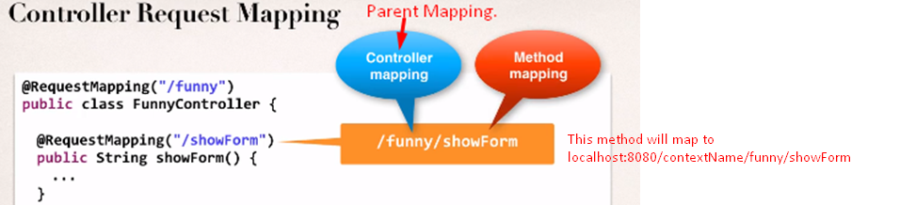  
   **Why at controller level:** A) To group request mapping B) To resolve conflicts.